GIT BASH

* Open git bash



* Creating new directory



* Change directory

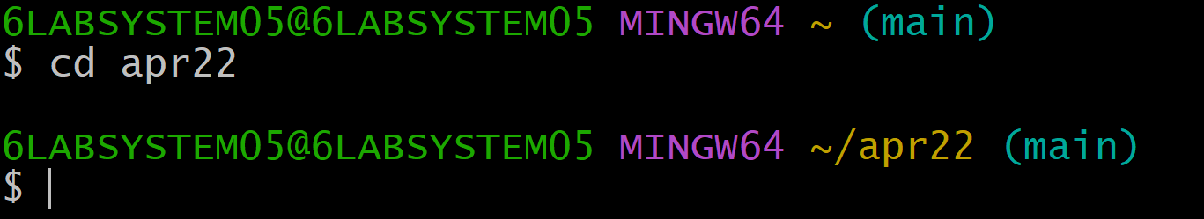

* Git init



* Create new file

